700120401638
87718297302 ватсап
Тел 87783404623

КАНАЕВА Карлыгаш Утегеновна,
Абай атындағы №31 жалпы білім беретін мектебінің ағылшын тілі пәні мұғалімі.
Түркістан қаласы

READING: MARRIAGE

Learning objectives(s) that this lesson is contributing to |  | 9.1.8.1 develop intercultural awareness through reading and discussion;  9.2.1.1 understand the main points in unsupported extended talk on a wide range of general and curricular topics;  9.3.2.1 ask complex questions to get information on a range of general and curricular topics;  9.4.2.1 understand specific information and detail in texts on a range of familiar general and curricular topics, including some extended texts;  9.6.9.1 use appropriately an increased variety of active and passive simple present and past forms and past perfect simple forms in narrative and reported speech on a range of familiar general and curricular topics;
Lesson objectives |  | All learners will be able to:  Identify the theme, new words and use them as the basis for discussion.  Demonstrate knowledge for usage of the Present Simple for retelling a story about arranged marriage.Transfer information from the given information into a graphic organizer.  Most learners will be able to:  Select, compile, and synthesize information for an oral presentation  - Provide a point of view in conversations and discussions; speak about arranged marriages using active vocabulary.  Some learners will be able to:  Respond to and discuss the reading passage using interpretive, evaluative and creative thinking skills.  Make a presentation about marriages in Kazakhstan.Respond to and discuss the reading passage using interpretive, evaluative and creative thinking skills.
Plan
Planned timings | Teacher’s activities |  | Student’s activities | Marks | Resources
Beginning of the lesson  5 min  5 min | Greeting.  Organizational moment: Establishes proper order in the classroom and greeting students. Then he takes a roll call and notes those who are absent.  The creative beginning of the lesson with the game "Fonts". With the help of ciphers, both groups guess the “coded” word.  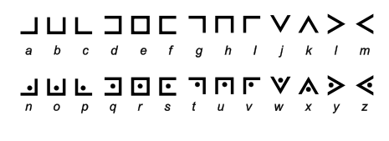  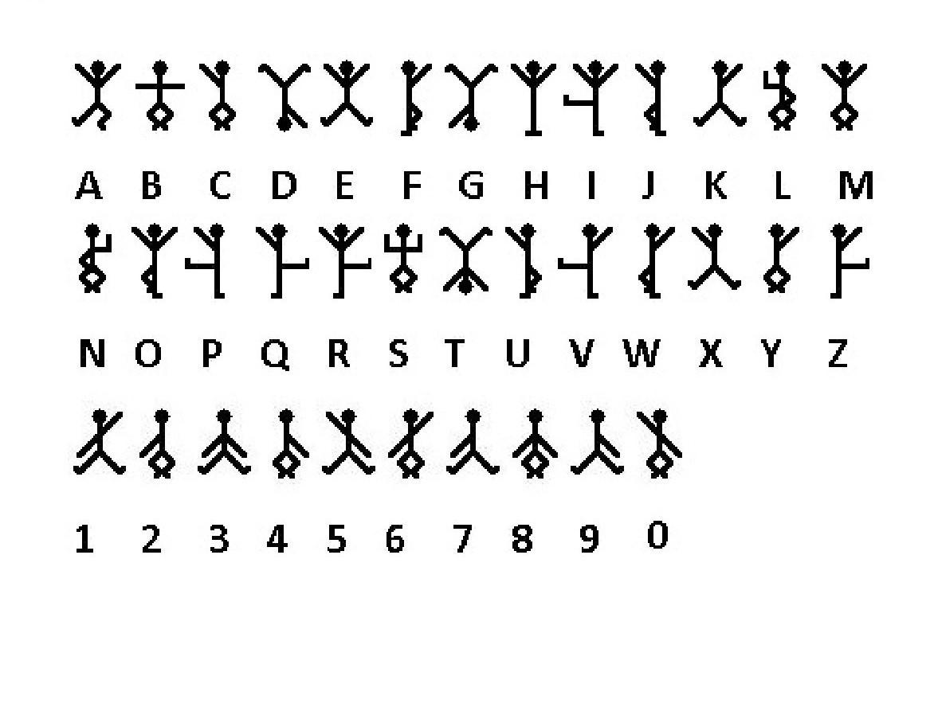  Checking homework:  - Orally question each student in order.  - Check whether you completed the task correctly: check the correct matching of the words “Already”, “Just”, “Still”, “Yet” for each sentence.  For each correctly completed task, one point for each student. |  | Students warm greet teacher  Each group guesses the words  Students read the written assignment with the correct answer. | 1 sticker for every correct answer    1 sticker for every correct answer   | Slide (useful phrases)  Pictures  PPT  Slide
5 min | Guess a new topic using pictures.  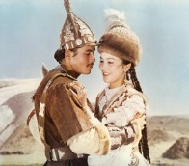    Warm up. Free talk.  Look at the pictures. What do you think is our topic today?  Mini game. Students throw the ball to each other while saying their associations with the word Marriage.  On the board you can see the word: Marriage  What do you imagine when you hear this word?  Please tell me your associations with this word. |  | Students answer the question |  | Student Book p.70  Pictures
Main  Activities  5 min  10 min  5 min | LISTENING TASK:  Listen to the text and express what you understand.  Read and translate the text for clear understanding.  Assessment criteria:  Identify the main idea in extended talks with little support.  Descriptor:  A learner:  - Apply topic related vocabulary in speech appropriately arranging words and phrases into well-formed sentences.  - Demonstrate the ability to participate in a conversation.  Reflection  Ex.2 p.70 True - false sentences.  Grammar  Explanation of the grammar of present perfect with since and for. Give examples.  Reflection  Ex. Fill in the missing places in the sentences since or for.  Assessment criteria:  Applying grammar while completing a task.  Descriptor:  Using the correct forms of preposition.  Insert correctly since and for into sentences  Creative exercise  Each group is given white posters and given a topic on which students should create a poster. The topic for the first group is “Facts about Indian marriage”, the topic for the second group is “Facts about Arab marriage”.  Assessment criteria:  Students create a poster on the theme of Indian-Arab marriage and perform with the poster.  Descriptor:  Students show their creative ideas  Telling facts about Indian/Arab marriage  All group members participate |  | Students listen, read and translate text into Kazakh  Students, based on the information received from the text, determine the veracity of the sentences.  Students have to listen carefully to the teacher and understand the grammar. Then insert correctly since and for into sentences  Students perform with the poster | Peer assessment  Formative assessment  Formative assessment  Oral Comments and Peer assessment | Student Book p.70  CD2.22  Slide on the board  Writing  Worksheet
Ending the lesson  10 min | Giving the home task: W.B. p.50  Students express their attitude to the lesson and give self-assessment by answering the following questions:  1. During the lesson I was Active/ passive  2. I am Satisfied/ not satisfied with my work  3. The lesson seemed to be Long/short  4. I am Tired/not tired  5. I feel Interested/bored  6. I think Got/didn't get the idea  7. The homework seems to be Easy/difficult  Gifts for students.  Thank you for your attention and participation in my lesson.

